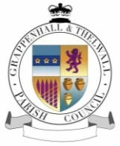
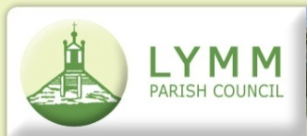

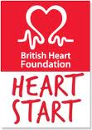
Heartstart Lymm
A scheme run by
Lymm & District Round Table

Contact:
Graham Gowland
32 Wychwood Av
Lymm
Cheshire
WA13 0NE
01925 751599
graham@gowland.me.uk

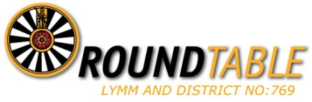

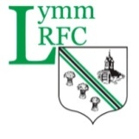

High Legh Parish Council
What is Heartstart Lymm?
Heartstart Lymm is an initiative to improve the emergency medical facilities in Lymm. It has developed in part through a national initiative set up by the British Heart Foundation, and is organised locally by Lymm & District Round Table. The local project has three main elements:
- Automatic External Defibrillators – there are now 16 public access defibrillators (AED’s) throughout Lymm village, all of which are registered with the North West Ambulance Service. With Circa 11,040 residents, that’s one AED per 690 people – probably the highest coverage in the country.
- First Aid Training – A monthly free first aid course is held in Lymm, open to all. There are also specific courses run for schools and community organisations. This is a general first aid course – it doesn’t just cover heart problems!
- Community First Responders – local people are being recruited to respond quickly to medical emergencies. In part because of the ship canal and M6 traffic it can take longer for ambulances to attend incidents in Lymm than the target 8 minutes, and this helps ‘plug the gap’.
The project in Lymm is capital funded by a number of bodies – Lymm Parish Council (main funder), Lymm & District Round Table and Lymm Rugby Club. It is also financially supported by a number of the community locations where the AED’s are located.

How Has The Project Expanded?
We have extended the project to Grappenhall & Thelwall, with the placing of 4 defibrillators funded by Round Table, Grappenhall & Thelwall Parish Council and Grappenhall Sports Club, as well as to High Legh, where one AED has been funded by the Parish Council, supported by Heartstart Lymm with local training.

Moving Forwards
We are becoming a key resource for the area in helping co-ordinate the placing of public access defibrillators, helping to advise a number of local colleges, parish councils and community organisations. We can help source a high quality defibrillator in an internal alarmed cabinet for around £850, or fitted in an external, secure cabinet for around £1,300 (Although we normally also suggest a maintenance pack that is around £200 for 7 years)
We intend to continue the regular training courses in Lymm, and are looking at setting up a youth focused training team to bring the course into schools and youth groups in the area.
We are continuing to help recruit Community First Responders, and have in our team a Paramedic who can train to this standard.

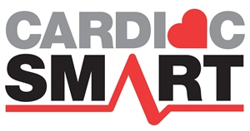
Recognition
We have been featured in many local publications publicising the project, and have recently won the CardiacSmart Gold Award – an award scheme run by the North West Ambulance service.

The Team
Course Director Dr Mike Hewitt-Symonds

Medical Advisor Dr Kirsty Challen

Training Supervisor Paul Knott

Course Co-Ordinator Graham Gowland

Course Bookings Tim Oakley

Finance Dr Richard Storey

Course Leaders Graham Gowland
Matt Stevenson

Assistant Trainers Hayley Owen
Jon Beesley,
Tracy Gowland
Lisa Hughes
David Hughes
Ian Newhouse
Chris Stephens
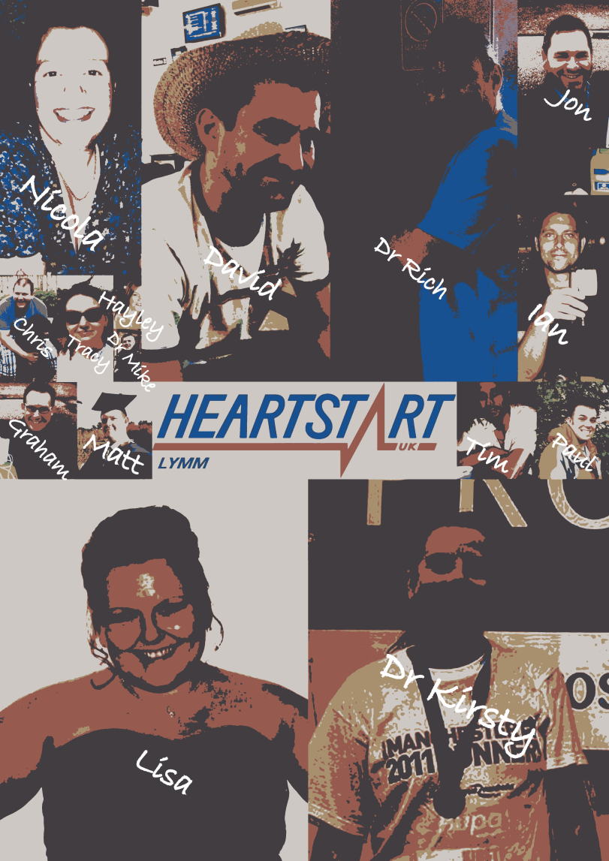
Nicola Storey

The Lymm Public Access Defibrillators
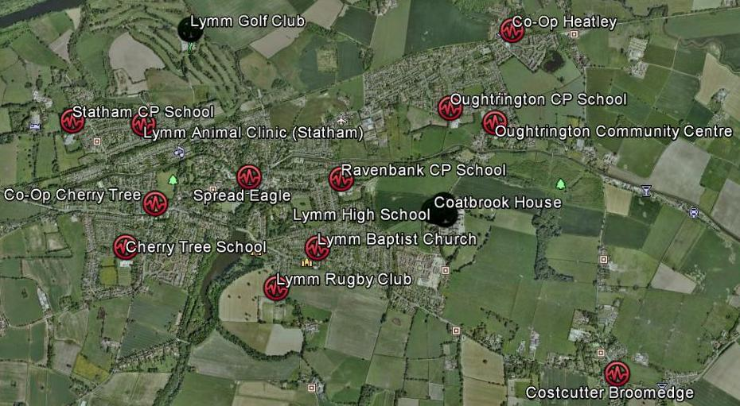

Grappenhall & Thelwall Public Access Defibrillators
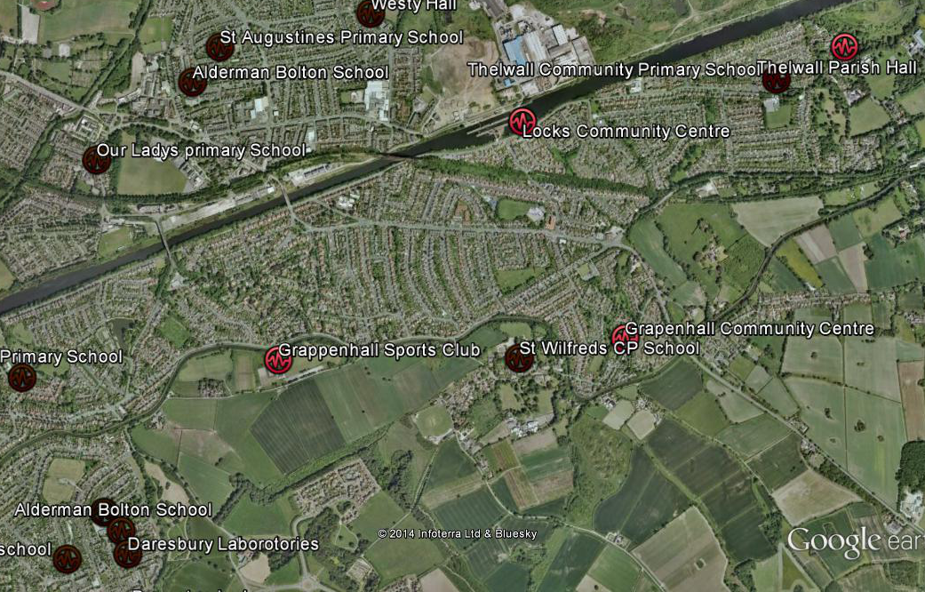

High Leigh Public Access Defibrillator
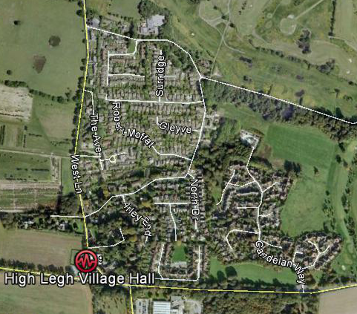
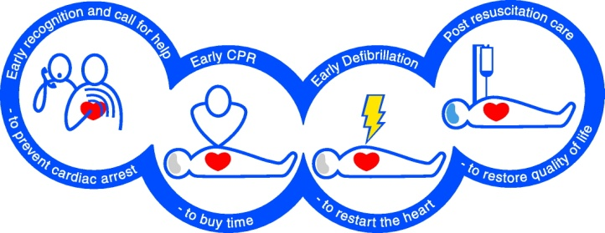
How Can You Help?
We need to spread the word of the impact community based schemes can on saving life. Around 25,000 people a year die in the UK each year, who may have survived if basic lifesaving skills were applied. It is simple steps that really do save lives – we call it the ‘Chain of Survival’, and anyone can apply the skills learnt on the Heartstart course to make a difference. The AED’s are a step in the chain of survival, but really the key element in our project is the training. It really is as simple as giving up 2 hours to learn the basic skills we teach on Heartstart.

1 Publicity

This is the Key element for us as the more publicity we can generate, the more people are likely to attend the training:

2 Photo Opportunities

These can be done without us being involved directly, but if you would like an actual AED in the picture or one of the team, please contact Graham Gowland on 01925 751599.

At one of our AED locations, pictured with:
Members of the Heartstart Team
Owner/manager of the building where we have sited an AED

At one of our Heartstart Courses
First Thursday in the Month at Lymm Baptist Church – 7.30pm start
Certificate Presentation – around 9.30pm

3 Press Stories

Obviously this can tie in with the photo ops, but this could include a mention in any regular column you do, or in your blog/newsletter

4 ‘Political’ Campaigns

Did you know that AED’s are VATable? While some organisations can have the VAT removed, surely this essential kit, and their accessories, should be Zero Rated?

Putting first aid on the school syllabus. It is such a simple step , but First Aid is not a requirement to teach in schools. The British Heart Foundation has a simple program aimed for delivery in school, either as a complete, stand-alone, practical course for pupils aged 10 years and over or a series of age-related, staged sessions for pupils aged 5 years and over with sessions tailored to reflect the recommended age at which children can learn specific First Aid skills. Wouldn’t it be great if teachers delivered this in the classroom? First aid is a skill for life that benefits individuals and communities.
- 98% of parents want first aid on the curriculum
- 98% of teachers want it on the curriculum
- 91% of pupils want to learn first aid at school
- First aid skills are simple to learn and can be taught by teachers with no prior first aid training,
- Research shows that first aid can make communities stronger and reduce the number of people visiting A&E.
- Research shows that children love learning first aid and are not afraid to use it when the time comes.
This means we have the potential to create a generation of life-savers.

5 Awards

It might be cheeky to suggest this, but the publicity around a community award can generate a lot of interest – for example the Big Society awards might be appropriate - www.bigsocietyawards.org. Nominating Heartstart Lymm for such an award could generate a lot of publicity for us, and so encourage people to come on the course. St Johns also has an award – ‘Organisation of the Year for First Aid Excellence’ http://www.sja.org.uk/everydayheroes/. Achieving a national award will achieve both press & TV coverage. We have referees that will support any applications listed below.

6 Attend the Course

You and of course family and friends are very welcome – please come and train with us.

7 Display a Poster

I’ve attached a copy of our course poster – anyone, Lymm resident or not, is welcome.

Any help you can give in encouraging more people to train in essential lifesaving skills would be very welcome.

Info:

Heartstart Lymm
C/O 32 Wychwood Avenue
Lymm
Cheshire
WA13 0NE

Tel
01925 751599
Contact
Graham Gowland

Email
graham@gowland.me.uk

Referees

The following independent people have agreed to endorse any awards nominations:

Nicholas Blair
Community Resuscitation Development Officer Cheshire & Merseyside Area
North West Ambulance Service NHS Trust
Elm House
Belmont Grove
LIVERPOOL
L6 4EG

Telephone: 0151 261 2521

Nicholas.Blair@nwas.nhs.uk

Mr Blair has verified our work to allow it to be registered with the ambulance service over the last year.

Cllr Ian Marks
80A Whitbarrow Road,
Lymm
WA13 9BA

Telephone: 01925 753051

imarks@warrington.gov.uk

Cllr Marks has helped with advice on local parish council funding and has followed the development of the project as a local councillor.

Almost everyone will be involved in a crisis at some point in their lives. Someone falls and can't get up. Someone cuts themselves and can't stop bleeding. Another person's heart fails. Wars, natural disasters, terrorist actions, plus all the day-to-day risks of car accidents, falling, ingestion of dangerous substances, among other possibilities, add up to a certainty any given individual will witness and maybe assist in first aid. Knowing what to do in these situations can be the difference between someone living or dying, between a temporary or permanent disability. First aid training is available at a number of institutions and is available to just about anyone.

Minutes Count
It takes the brain six minutes to die once oxygen is cut off. It can take a person as little as five minutes to bleed to death. Bones that are not set, may never hold weight. Cuts that are not cleaned can become infected. In the minutes after a trauma, how the body is treated can make a world of difference to the outcome, and time is of the essence.

ABC's of First Aid
First aid addresses three critical issues: Airway, making sure that the person can breathe; Blood, making sure the person is not going to bleed to death; Cardio, making sure the person's heart is beating. Beyond that first aid is about making sure no more damage is done and making the victim as comfortable as possible. First aid might be as simple as putting alcohol and a bandage on a scrape, immobilizing bones so surrounding tissue isn't damaged, or it might be as intense as restoring breathing and heart beat. First aid can also be psychological, aiding people who are so traumatized that they may not be functional, and they need support and guidance to move forward and make safe decisions.

First aid is absolutely essential in emergency situations; you may be thinking like millions of others... when am I ever in an emergency situation? If the answer is never, you are incredibly lucky. There has been thousands of cases where heart attacks, burns, electrocutions, falls, spinal injuries, choking and bleeding have all gone untreated until members of the emergency services have arrived on scene.

The ability to carry out first aid before paramedics arrive can really minimise a casualty’s damage, help aid their recovery and even ensure their survival. That casualty may be a loved one, a friend or a stranger, no matter who they are...they will all have one thing in common…they will need your immediate help.

Imagine the situation. You have been for a walk around your local reservoir, it is a hot day, children are playing and the birds are singing. Out the corner of your eye you see a group of friends all huddled around by the water’s edge panicking. You run over to investigate, on arriving you see a boy who isn’t breathing. It is obvious he has been in the water. Unlike those crowding around the boy, you aren’t in a state of panic. You know what action to take immediately. Your training kicks in.

Within a split second you have taken control of the situation and are administering CPR whilst another member of the group phones the emergency services. After administering CPR the boy splutters back into life. You comfort him until the emergency services personnel arrive and take him to hospital. You have saved a life. Alternatively, you can stand around not knowing what to do, watching the boy drifting in and out of consciousness, praying for the already overstretched ambulance crews to hurry up.

First aid is essential in emergency cases. Knowing what action needs to be taken to control an emergency can make the difference between life and death. Emergencies occur all around us, in all spheres of life. Someone may be injured at work, school or at home. When this happens, first aid basics will equip anyone around the injured person to reduce the danger posed by the accident.

For example, if a child breaks a limb during play time at school, an attending teacher may perform first aid to help reset the bones and reduce any pain and discomfort the child may be experiencing. In cases where the injury causes profuse bleeding, first aid is necessary to reduce the chances of extensive blood loss. Ambulances hardly arrive immediately, and first aid makes all the difference in the time it takes the ambulance to arrive.

What is included in basic first aid training?

First Aid is a broad subject. Most courses are usually designed to cover basic techniques used in first aid. Some common topics that may be covered in short first aid courses include: making an initial assessment of a victim, how to detect an emergency, how to protect yourself from any infections, effective control of bleeding wounds, dealing with broken bones, head and neck injuries, heart attacks, strokes, heat exhaustion, shortness of breath, and hypothermia.

The most important lesson is when to call emergency services and describing the emergency scene to an emergency operator. The more details they have, the better prepared medical emergency teams are when they arrive on the scene. For example, a description of the victim’s wounds, their ability to respond and the extent of damage. First aid training may take a day or a couple of months. The length of classes determines how much information is acquired. Registering for a full first aid course is recommended, since it prepares individuals for any emergency they might encounter.

First aid does not eliminate the need for a hospital.

First aid is used to contain an emergency situation. As soon as any injuries are under control, the victim should be checked by a doctor. This will ensure that no further damage is caused in the future. For example, first aid may contain injuries from a fall, but it does not detect or stop internal bleeding. Going to the hospital will ensure that there is no internal bleeding. For small cuts or burns, first aid may be sufficient treatment for the injured person. It is best to weigh the situation critically before determining whether to go to a hospital or not.

Who needs first aid training?

First aid basics are a good skill to have for anyone. It is necessary for people dealing with children to know basic first aid. This includes parents, teachers, and nannies. Workers who are regularly exposed to dangerous machinery need to have first aid skills in case of injuries. Travel buffs may find it necessary to know first aid, especially if they spend a lot of the time outdoors. This is due to the risk of bug and spider bites, or breaking limbs while hiking.

First aid has been proven to save lives. Learning basic first aid will help anyone save a life in an emergency.

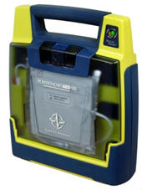
What is an Automated External Defibrillator
An automated external defibrillator or AED is a portable electronic device that automatically diagnoses the potentially life threatening cardiac arrhythmias of ventricular fibrillation and ventricular tachycardia in a patient, and is able to treat them through defibrillation, the application of electrical therapy which stops the arrhythmia, allowing the heart to re-establish an effective rhythm.

AEDs are designed to be simple to use for the layman, and the use of AEDs is taught in many first aid course, including Heartstart.

Conditions that AED’s Treat
An automated external defibrillator is used in cases of life threatening cardiac arrhythmias which lead to cardiac arrest. The rhythms that the device will treat are usually limited to:

- Pulseless Ventricular tachycardia (shortened to VT or V-Tach)
- Ventricular fibrillation (shortened to VF or V-Fib)

In each of these two types of shockable cardiac arrhythmia, the heart is active, but in a life-threatening, dysfunctional pattern. In ventricular tachycardia, the heart beats too fast to effectively pump blood. Ultimately, ventricular tachycardia leads to ventricular fibrillation. In ventricular fibrillation, the electrical activity of the heart becomes chaotic, preventing the ventricle from effectively pumping blood. The fibrillation in the heart decreases over time, and will eventually reach asystole. AEDs, like all defibrillators, are not designed to shock asystole ('flat line' patterns) as this will not have a positive clinical outcome. The asystolic patient only has a chance of survival if, through a combination of CPR and cardiac stimulant drugs, one of the shockable rhythms can be established, which makes it imperative for CPR to be carried out prior to the arrival of a defibrillator.

Effect of Delayed Treatment
Uncorrected, these cardiac conditions (ventricular tachycardia, ventricular fibrillation, asystole) rapidly lead to irreversible brain damage and death. After approximately three to five minutes, irreversible brain/tissue damage may begin to occur. For every minute that a person in cardiac arrest goes without being successfully treated (by defibrillation), the chance of survival decreases by 23 percent.

Requirements for use
AEDs are designed to be used by laypersons who ideally should have received AED training. This is in contrast to more sophisticated manual and semi-automatic defibrillators used by health professionals, which can act as a pacemaker if the heart rate is too slow (bradycardia) and perform other functions which require a skilled operator able to read electrocardiograms.

A study analyzed the effects of having AEDs immediately present during Chicago's Heart Start program over a two year period. Of 22 individuals 18 were in a cardiac arrhythmia which AEDs can treat (Vfib or Vtach). Of these 18, 11 survived. More interestingly, of these 11 patients, 6 were treated by good Samaritan bystanders with absolutely no previous training in AED use.

Placement and Availability
Automated external defibrillators are generally either held by trained people, or are public access units which can be found in places where people may congregate. The location of a public access AED should take in to account where large groups of people gather, regardless of age or activity. Children as well as adults may fall victim to sudden cardiac arrest (SCA)
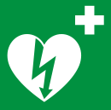
In order to make them highly visible, public access AEDs often are brightly coloured, and are mounted in protective cases. AED operators should know to phone for an ambulance when sending for or using an AED. In September 2008, the International Liaison Committee on Resuscitation issued a 'universal AED sign' to be adopted throughout the world to indicate the presence of an AED.

Mechanism of operation
An AED is external because the operator applies the electrode pads to the bare chest of the victim, as opposed to internal defibrillators, which have electrodes surgically implanted inside the body of a patient. Automatic refers to the unit's ability to autonomously analyse the patient's condition, and to assist this, the vast majority of units have spoken prompts, and some may also have visual displays to instruct the user. When turned on or opened, the AED will instruct the user to connect the electrodes (pads) to the patient. Once the pads are attached, everyone should avoid touching the patient so as to avoid false readings by the unit. The pads allow the AED to examine the electrical output from the heart and determine if the patient is in a shockable rhythm (either ventricular fibrillation or ventricular tachycardia). If the device determines that a shock is warranted, it will use the battery to charge its internal capacitor in preparation to deliver the shock. This system is not only safer (charging only when required), but also allows for a faster delivery of the electrical current.

When charged, the device instructs the user to ensure no one is touching the patient and then to press a button to deliver the shock; human intervention is usually required to deliver the shock to the patient in order to avoid the possibility of accidental injury to another person (which can result from a responder or bystander touching the patient at the time of the shock). Depending on the manufacturer and particular model, after the shock is delivered most devices will analyze the patient and either instruct CPR to be given, or administer another shock.

Many AED units have an 'event memory' which store the ECG of the patient along with details of the time the unit was activated and the number and strength of any shocks delivered. Some units also have voice recording abilities to monitor the actions taken by the personnel in order to ascertain if these had any impact on the survival outcome. All this recorded data can be either downloaded to a computer or printed out so that the providing organisation or responsible body is able to see the effectiveness of both CPR and defibrillation.

The first commercially available AEDs were all of a monophasic type, which gave a high-energy shock, up to 360 to 400 joules depending on the model. This caused increased cardiac injury and in some cases second and third-degree burns around the shock pad sites. Newer AEDs (manufactured after late 2003) have tended to utilise biphasic algorithms which give two sequential lower-energy shocks of 120 - 200 joules, with each shock moving in an opposite polarity between the pads. This lower-energy waveform has proven more effective in clinical tests, as well as offering a reduced rate of complications and reduced recovery time.

Simplicity of use
Unlike regular defibrillators, an automated external defibrillator requires minimal training to use. It automatically diagnoses the heart rhythm and determines if a shock is needed. Automatic models will administer the shock without the user's command. Semi-automatic models will tell the user that a shock is needed, but the user must tell the machine to do so, usually by pressing a button. In most circumstances, the user cannot override a "no shock" advisory by an AED. Some AEDs may be used on children - those under 55 lbs (25 kg) in weight or under age 8. If a particular model of AED is approved for pediatric use, all that is required is the use of more appropriate pads. Some organizations, such as the American Heart Association, recommend that if pediatric AED pads are not available, adult pads should be used to determine if the child is in a shockable rhythm. There is insufficient evidence to suggest that a child, in a shockable cardiac arrest, can be "hurt" by an adult defibrillation energy setting.

All AEDs use an electronic voice to prompt users through each step. Because the user of an AED may be hearing impaired, many AEDs now include visual prompts as well. Most units are designed for use by non-medical operators. Their ease of use has given rise to the notion of public access defibrillation (PAD), which experts agree has the potential to be the single greatest advance in the treatment of out-of-hospital cardiac arrest since the invention of CPR.

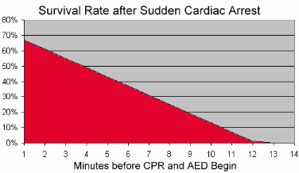
Why Have a Defibrillator

Life expectancy
Following a Cardiac Arrest the chance of survival decreases by 10 to 23% per minute. It is therefore very important medical treatment starts as soon as possible. The UK Resuscitation Council suggests an AED should be available wherever medical treatment is more than 5 minutes away. In practical terms this means the whole of the UK, but in Lymm this can be considerably longer.

About Defibrillators or AEDs:
A defibrillator delivers an electrical current through the chest which aims to shock the heart back into a normal rhythm allowing it to pump again. Rapid response using automated technology can significantly improve the quality of life of a survivor, as the longer the brain is starved of oxygen, the more damage that can occur. An AED is a portable defibrillator especially designed for people with no medical background. When applied to the victim, voice commands and screen messages will guide the user step-by-step through the process and its intelligent technology will only allow it to shock a ‘shockable’ heart rhythm. AED technology opens a window for the public to take on a key role to support emergency services who would otherwise be hindered by the time it takes to reach the victim.

About Sudden Cardiac Arrest:
Sudden Cardiac Arrest or SCA is an electrical malfunction of the heart (most commonly Ventricular Fibrillation) in which the heart stops pumping blood to the body and brain due to an abnormal heart rhythm known as an arrhythmia. As the victim consecutively loses pulse, consciousness and ability to breathe, the victim is termed “clinically dead” and can only be physically brought back to life in a very small window of time using a defibrillator or AED.

Survival rate: 5% with CPR alone; 50% with defibrillation

The rate of survival of an SCA is dependent upon time. The quicker the intervention, the better the outcome. Brain death starts after 3 minutes so urgent action is needed, particularly in areas where it can take several minutes to get a competently trained person to the scene.

Recent evidence suggests that public access defibrillation is almost 10x more effective in saving lives than Community First Responder schemes alone. This is nothing to do with skills of the responders, but simply a factor of time to the patient. To give a good outcome, medical help needs to be present at the patient within 4-5 minutes.

